Climate exerts a fundamental influence on the water quality of Lake Coeur d’Alene through its influence on the magnitude, frequency, and timing of inflows to the lake system. The climate interacts with the topography, geology, and land-cover of the Lake Coeur d’Alene watershed in complex and nonlinear ways to give rise to the hydrologic regimes that characterize the inflows to the lake. This chapter focuses on the climatic drivers and hydrologic response within the major subwatersheds of Lake Coeur d’Alene through the lens of the historical patterns that give rise to conditions in the lake, and recent and projected change in hydroclimate that will influence inflows to the lake in the future.

Contemporary and Near-Historical Climatology

The climate of the Lake Coeur d’Alene watershed is characterized by cold and wet winters followed by warm and dry summers. Mean annual precipitation within the Lake Coeur d’Alene watershed between the period of 1991-2020 is estimated to be 1090 mm/year [Daly et al., 2008; 2015]. There is significant spatial variation to the mean annual precipitation within the watershed associated with orographic effects. At lower elevations within the watershed – in the vicinity of the lake – mean annual precipitation is as low as 600 mm/year. Conversely, at the highest elevation locations within the lake’s watershed, mean annual precipitation for the 1991-2020 period exceeds 1800 mm/year.

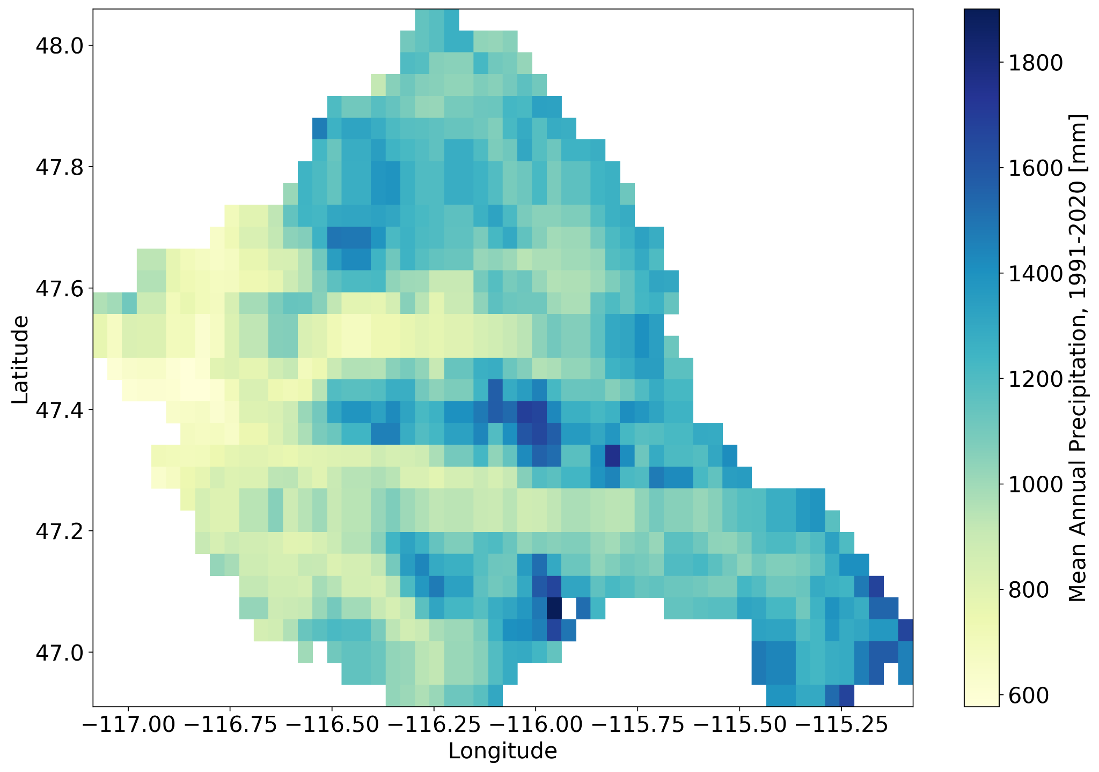

Mean annual precipitation varies slightly between the St. Joe River (1129 mm/year), Upper Coeur d’Alene River (1162 mm/year), and South Fork Coeur d’Alene River (1169 mm/year) watersheds. The collection of small catchments that drain directly to Lake Coeur d’Alene are associated with a significantly lower mean annual precipitation (876 mm/year), owing primarily to a lower distribution of elevations than any of the tributaries.

As mentioned above, precipitation timing throughout the watershed varies significantly throughout the year. Based on analysis of the 30-year period between 1991-2020, the months of November through January are typically associated with the highest precipitation throughout the year, with the watershed receiving on average more than 140 mm/month of precipitation in these months based on a 30 year average between 1991-2020. Precipitation is lowest in the summer months of July through August with monthly average precipitation values of less than 40 mm/month in each of these months during the 30-year period from 1991-2020. The variability in long-term average monthly precipitation between subwatersheds is smaller than the seasonal variability.

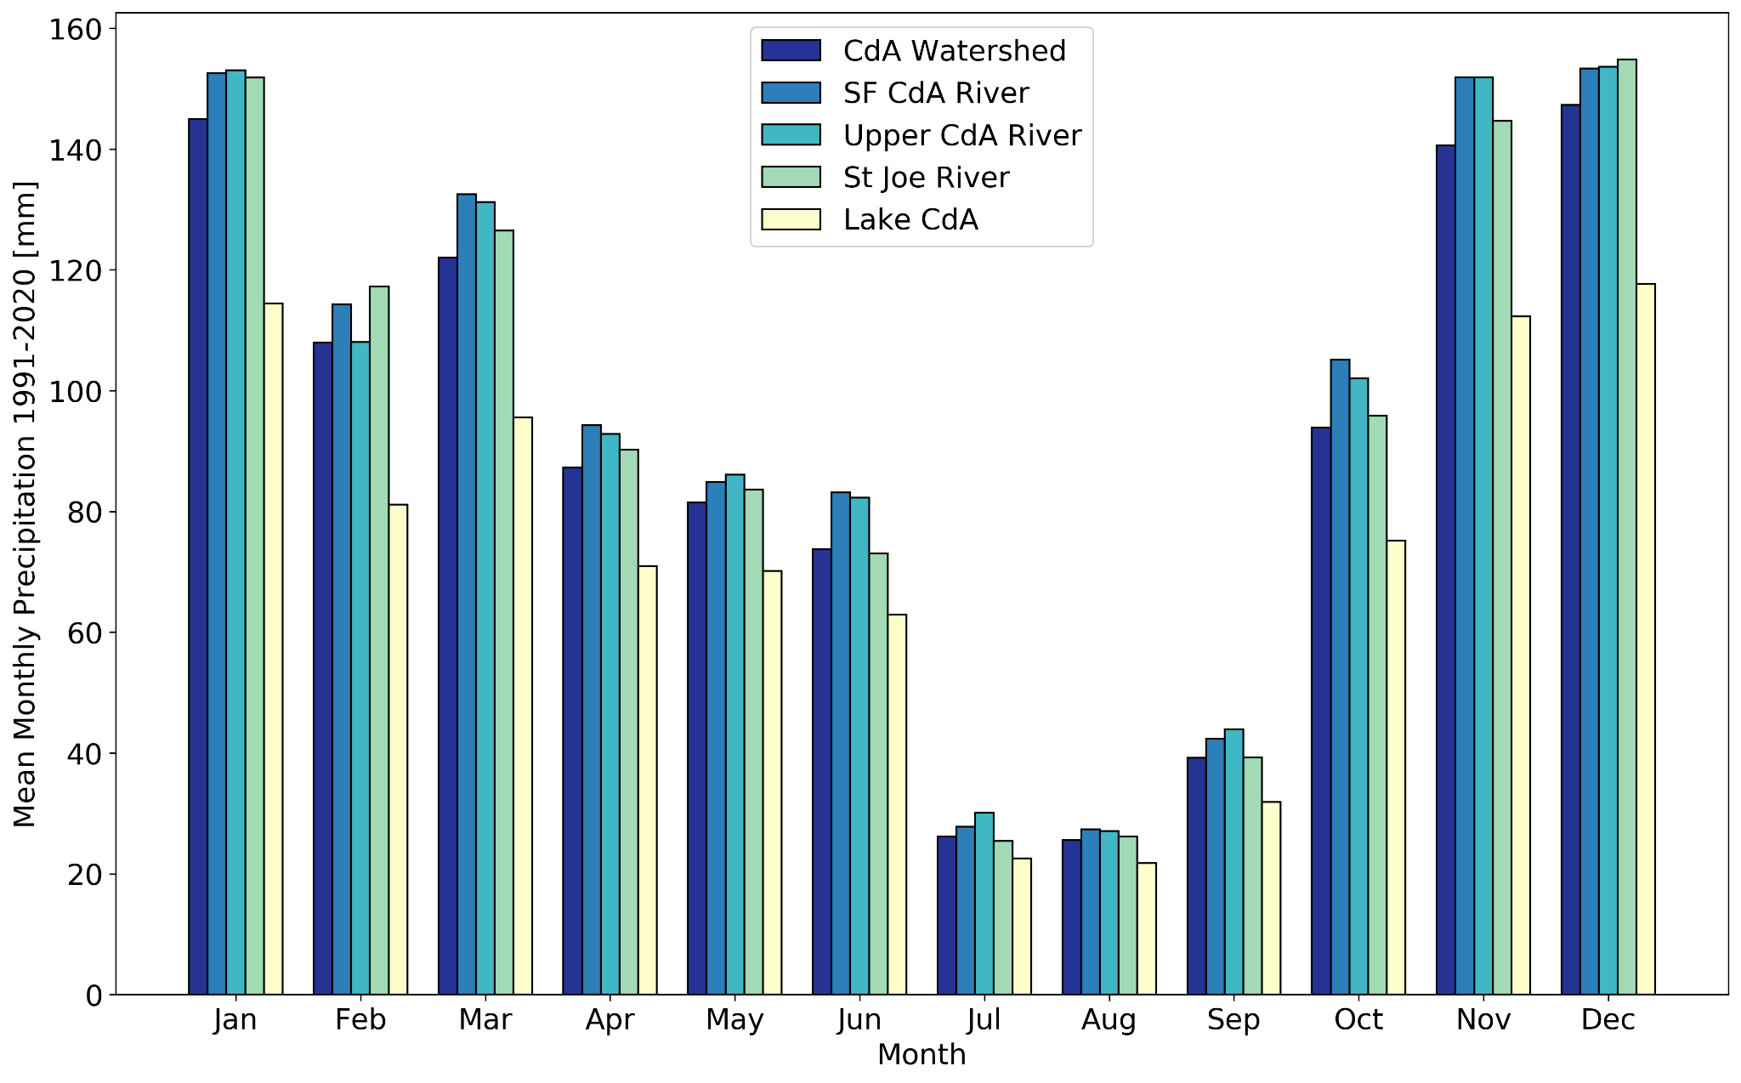

In addition to the spatial variation of mean annual precipitation, the annual volume of precipitation within the Lake Coeur d’Alene watershed exhibits significant interannual variability. Over the 30-year period between 1991-2020, the annual total precipitation has varied between 824 mm/year in 2019 to as high as 1505 mm/year in 1996 within the watershed. As might be expected, there the interannual variability in annual precipitation volume is consistent in timing across the subwatersheds.

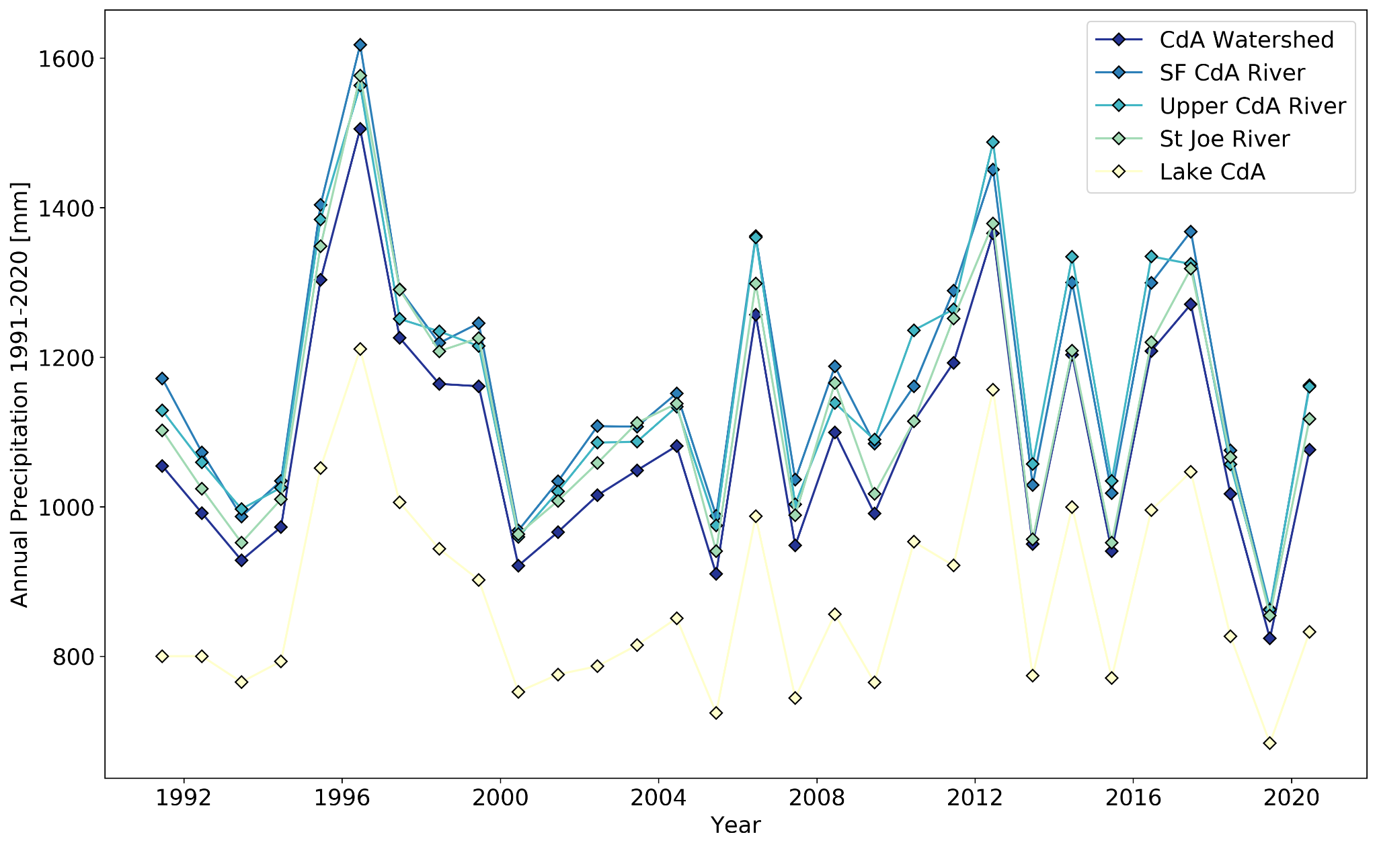

The Coeur d’Alene watershed is also associated with large seasonal variations in temperature. The watershed-average daily maximum temperature ranges from slightly less than 0 °C in January to approximately 25 °C in July and August. Conversely the watershed-average daily minimum temperature ranges from slightly less than -5 °C in January to approximately 9 °C in July and August.

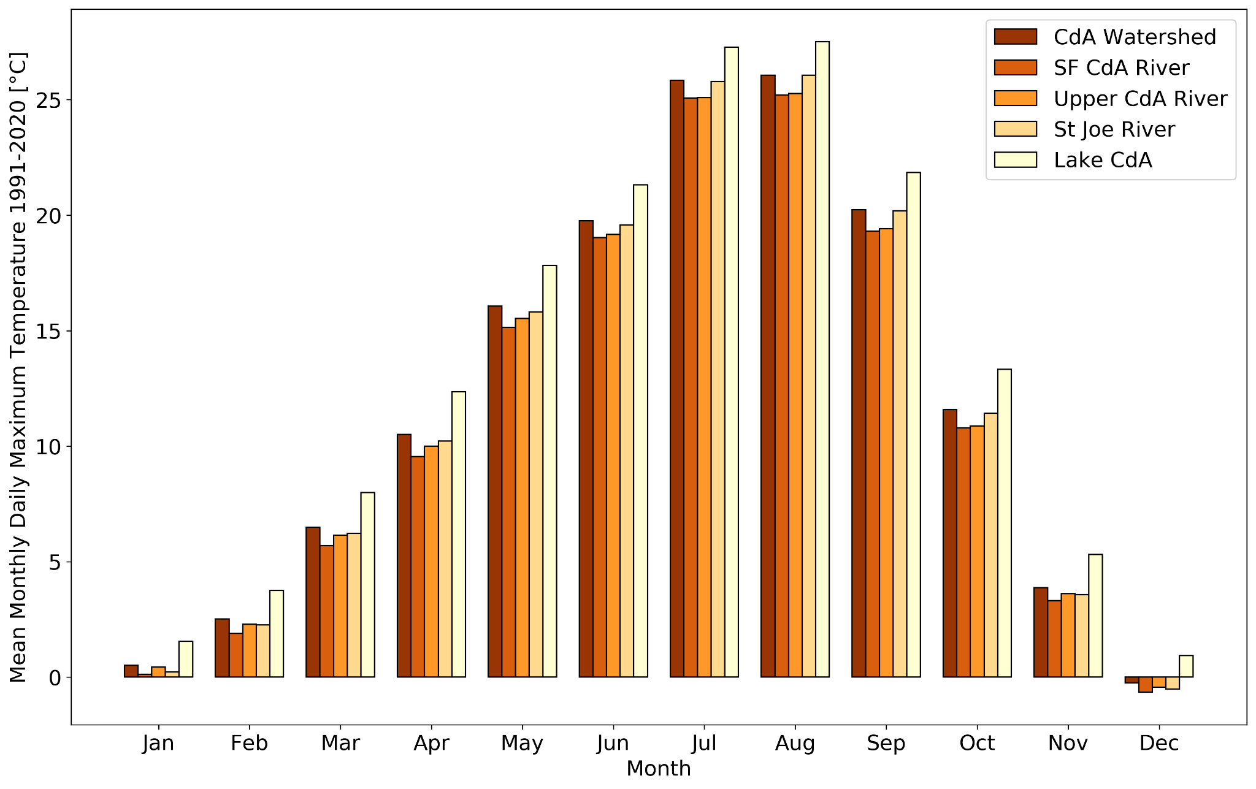

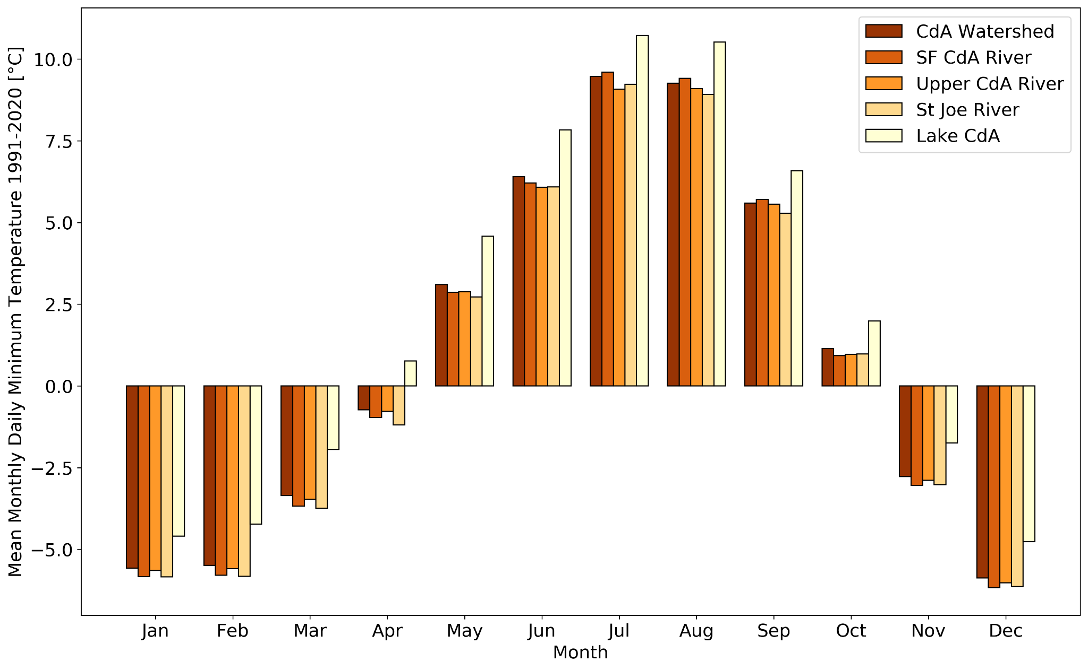

Monthly average temperatures at the watershed scale can also vary significantly from year-to-year. Between 1991-2020, the range of monthly averaged daily maximum temperatures varied by up to 5 °C in December and January and up to approximately 8 °C in July. Monthly average daily minimum temperature, by contrast, exhibits the greatest variability in the winter months of December through February, and the least variability in the spring months of April through June. The large elevation gradient within the Coeur d’Alene watershed gives rise to significant spatial heterogeneity in temperatures in all seasons.

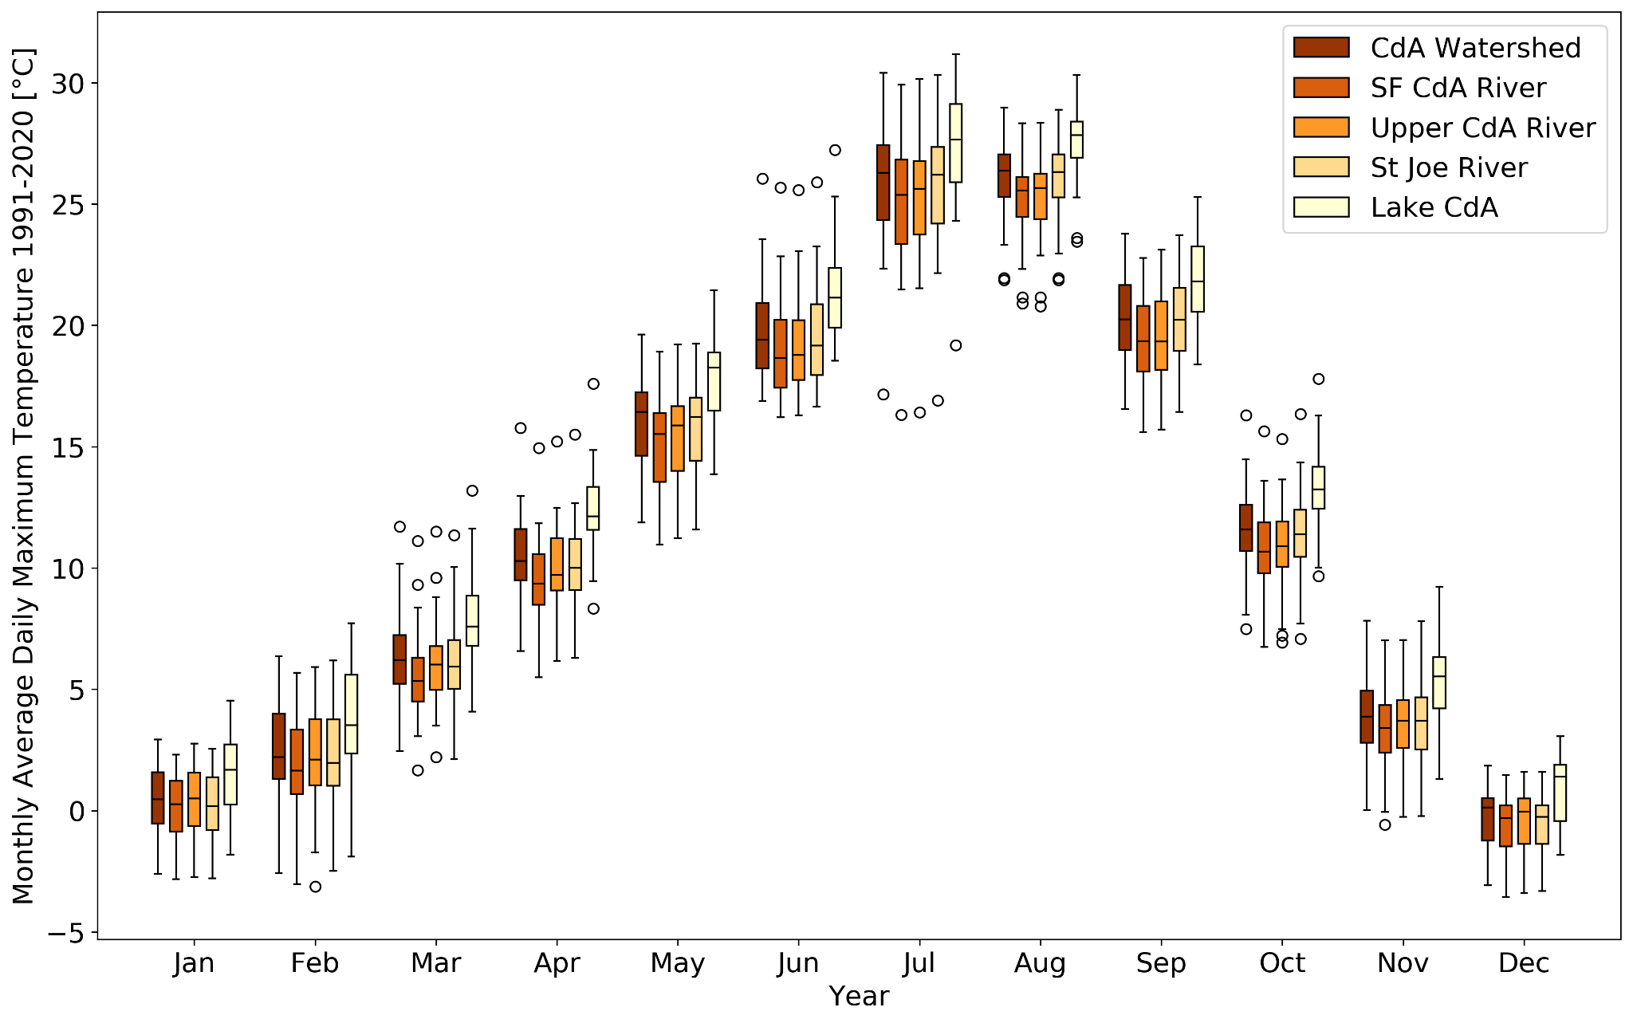

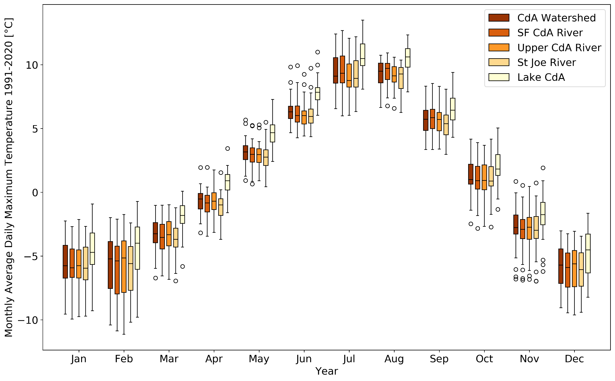

Hydrology

The observed seasonal patterns in precipitation and temperature within the Lake Coeur d’Alene watershed result in the bulk of precipitation delivered to the watershed arrives as snow. The snow-dominated nature of precipitation delivery to the watershed exerts a fundamental control on the hydrologic regimes of the tributaries to Lake Coeur d’Alene.

The USDA Natural Resources Conservation Service (NRCS) monitors snowpack conditions in the Lake Coeur d’Alene River watershed through a network of Snow Telemetry (SNOTEL) automated measurement stations and manual snow course measurement sites. Through this network of sites the NRCS develops a basin scale analyses of snow water storage estimates for the Spokane River watershed, to which the Coeur d’Alene River watershed comprises the primary tributary. Based on the 30 year period between 1991-2020, the NRCS estimates that the median peak Snow Water Equivalent (SWE) in the Spokane River Watershed is approximately 650 mm and the median date of maximum SWE occurs around April 1. There is, however, significant interannual variability in the magnitude and timing of peak SWE conditions. Over the 30-year period ending in 2020, peak SWE in the Spokane River watershed has been as low as approximately 250 mm and occurred as early as March 1. At the other extreme, peak SWE has been as high as 1100 mm and the date of maximum SWE has been as late as May 3.

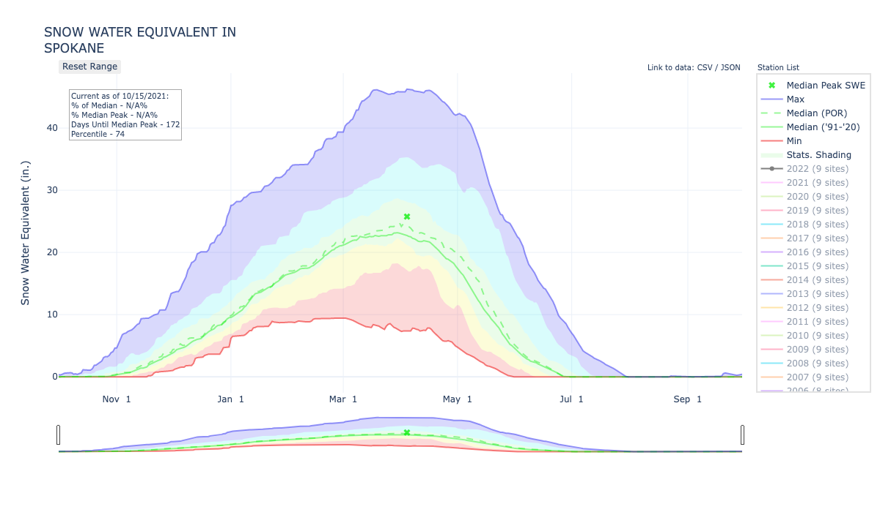

The subwatersheds that contribute flow to Lake Coeur d’Alene include the St. Joe River, South Fork, North Fork, as well as a number of smaller watersheds and catchments that are immediately adjacent to the lake. Owing to the fact that the bulk of the precipitation that is delivered to the watershed arrives as snow, the hydrology of the lake’s major contributing watersheds are characterized by a snowmelt-dominated regime. The rate and timing of snow accumulation, retention, and release is directly reflected in the hydrographs of the rivers that contribute to Lake Coeur d’Alene.

* TODO: Some specifics here? 2-year flows/50 year flows? Check out Jim’s streamflow analysis

Climate Change and Hydrologic Response

The committee invited Dr. Guillaume Mauger from the University of Washington's Climate Impacts Group (CIG) to provide an overview of projected changes in climate within the Lake Coeur d’Alene watershed specifically, and the broader interior Pacific Northwest, more broadly. The facets of climate change that will potentially influence the future of water quality in Lake Coeur d’Alene include the magnitude of temperature warming that the Coeur d’Alene watershed will experience, the degree to which global climate change will change the amount and timing of precipitation delivered to the watershed, and the extent to which regional climate warming in conjunction will shift the delivery of precipitation from snow to rain.

The degree of projected warming in the Pacific Northwest region varies significantly based on the associated emissions scenario examined. For the neighboring state of Washington, by the year 2050 a low greenhouse gas emissions scenario (Representative Concentration Pathway 4.5, RCP4.5) is associated with an average warming of 2.4 °C across multiple climate models, and a range of 1.1 °C to 3.7 °C across those same models, relative to the 1950-1999 period. A higher global greenhouse gas emissions scenario – the RCP8.5 scenario – is associated with an average warming of 3.2 °C and a range of warming from 1.7-4.7 °C across different climate models by the year 2050, relative to the 1950-1999 period [Dalton et al., 2013].

There exists considerable uncertainty in climate change projections regarding both the direction and degree of future changes in mean annual precipitation over the Coeur d’Alene watershed, as well as how any changes in mean annual precipitation are partitioned throughout the course of the year [REF]. An important element to any changes in precipitation regimes in the Coeur d’Alene River watershed, however, is the degree to which any climate change leads to shifts in the magnitude and frequency of extreme precipitation events. Work by Warner et al. [2015] suggests that those events with a daily precipitation in the top 1% of historical daily precipitation volumes are likely to become between 5-34% more intense by the 2080s in the Pacific Northwest region.

An important aspect of changes in temperature regimes within the watershed are the degree to which increases in temperature drive shifts in precipitation phase from snow to rain. Of particular interest in the context of climate change are future potential shifts in the elevation of the rain-snow transition. In a set of modeling experiments in which downscaled outputs from the third Coupled Model Intercomparison Project (CMIP3) was used as input to the Variable Infiltration Capacity (VIC) model, version 4.0.7. Using a temperature threshold approach to partition precipitation into rain versus snow, the model simulates the response of the processes of snow accumulation, retention, and release. Examining model projections for a moderate global greenhouse emissions scenario, the model suggest that – depending on the climate model used as input – peak SWE in the Pacific Northwest could decrease by between 27-79% by the 2040s, with an average of a 51% reduction in SWE across all models. By the 2080s, the modelling experiments suggest that SWE could decrease by between 44-96% depending on the specific climate model inputs to VIC, with an average of a 73% reduction in peak SWE. These potential reductions in the amount of water stored in the snowpack have potentially profound implications for runoff hydrographs, as discussed in the following section.

* TODO: Rain-snow shifts already observed within region… check Charlie Luce’s work
* TODO: Newer and more specific projections for the Spokane/CdA watershed with CMIP5 data?
* TODO: Hypsometry… what fraction of the lake’s watershed is at higher elevations?

Hydrologic projections

The model-based studies performed by CIG using downscaled outputs of the CMIP3 suite of climate models also yielded hydrographs from the VIC model. Of particular consequence to water quality conditions in Lake Coeur d’Alene are what these hydrographs suggest about the occurrence of extreme flows and the timing of flows. The results of the model projections exhibit some uncertainty in terms of low flows as measured by the minimum average annual streamflow that can be expected to occur for a seven day period once every ten years (7Q10). Results suggest that 7Q10 would decrease by about 1% by the 2040s and 2% by the 2080s. However, across all model simulations future changes in 7Q10 varied from -5% to +2% by the 2040s and -6% to +2% by the 2080s, indicating that the simulations are not entirely consistent in terms of the potential direction of change. Peak flows, as measured by the 100 year return interval event (Q100), were projected to increase by approximately 39% in the 2040s and 61% in the 2080s. But again, the modeling scenarios exhibit large ranges of variability in the change of Q100, with all of the model simulations suggesting a range of change to Q100 of between -6% to +98% by the 2040s and +33% to 146% in the 2080s. A far more consistent result, however, was found in terms of the center of timing in the streamflow hydrographs of the projections. The center of timing coincides with the day of the water year associated with 50% of the annual volume of streamflow being exceeded. In the Pacific Northwest, the historic center of timing of the annual hydrograph occurred on approximately April 15 in the 1980s. By the 2040s, the models suggest that the center of timing would occur earlier with dates ranging from March 4 to March 31, and an average date of occurrence of March 18. This is approximately 1.5 to 0.5 months earlier than the historical date of occurrence of the center of the hydrograph. The model simulations suggest that by the 2080s the center of the hydrograph would occur between February 10 and March 13, with an average across all of the climate models considered of March 3. This earlier occurrence of the center of the runoff hydrograph is consistent with both a number of other modeling studies in the region and the western US, more broadly, and is consistent with warmer winters leading to increases in the fraction of precipitation occurring as rain, rather than snow. It is also consistent with the model-based suggestions of large reduction in the peak SWE in the region during the same periods of time.

CIG has also conducted a suite of newer simulations examining the hydrologic impacts of climate change throughout the Pacific Northwest using the newer CMIP5 climate model projections and improved process representations in the VIC model, and the addition of another model the Precipitation-Runoff Modeling System (PRMS) [REF]. In particular, these newer projections were developed by using downscaled climate model outputs from XX climate models and two different downscaling techniques, and four alternative hydrologic models. These hydrologic models coincide with three alternative configurations of the VIC model [REF] and one configuration of PRMS [REF]. Streamflow projections developed by CIG contain simulated streamflows at USGS two streamflow gages within the Coeur d’Alene watershed, the St. Joe River at Calder (USGS station number 12414500) and the North Fork Coeur d’Alene River above Shoshone Creek near Prichard (USGS station number 12411000).

* What do models suggest about 7Q10, Q100, and center timing?
* All four models were calibrated to historical streamflow… how? Which gages? For how long? What variables were calibrated?

Climate Change and Aquatic Thermal Regimes

* TBD

REFERENCES

Daly, C., Halbleib, M., Smith, J.I., Gibson, W.P., Doggett, M.K., Taylor, G.H., Curtis, J., and Pasteris, P.A. 2008. Physiographically-sensitive mapping of temperature and precipitation across the conterminous United States. International Journal of Climatology, 28: 2031-2064

Daly, C., J.I. Smith, and K.V. Olson. 2015. Mapping atmospheric moisture climatologies across the conterminous United States. PloS ONE 10(10):e0141140. doi:10.1371/journal.pone.0141140

Dalton, M.M., Mote, P.W. and Snover, A.K., 2013. Climate Change in the Northwest. IslandPress.

US Department of Agriculture Natural Resources Conservation Service, National Water and Climate Center Basin Reports, https://www.nrcs.usda.gov/wps/portal/wcc/home/quicklinks/imap

Warner, M.D., Mass, C.F. and Salathe Jr, E.P., 2015. Changes in winter atmospheric rivers along the North American west coast in CMIP5 climate models. Journal of Hydrometeorology, 16(1), pp.118-128.